Release Notes: Bird Watching App

Version 1.1

Overview

This release introduces significant enhancements to the Bird Watching App, focusing on user experience, functionality, and innovative features. The following changes have been implemented:

Key Features:

\* Miles/Kilometers Setting: Users can now toggle between miles and kilometers for distance measurements, providing flexibility and customization.

\* Add Bird Sighting Feature: Users can easily log new bird sightings, including species, location, and a brief description. This feature empowers users to contribute to a growing database of bird observations.

\* Map Directional Lines: Improved map navigation with directional lines to guide users from their current location to a specific bird sighting or point of interest.

\* All Bird Markers: Visualize all bird sightings on the map simultaneously, providing a comprehensive overview of bird activity in the area.

Technical Improvements:

\* Firebase Integration: Migrated from SQLite to Firebase Realtime Database for robust data storage and synchronization across devices.

\* Code Optimization: Implemented performance optimizations to ensure smooth app operation, especially on lower-end devices.

\* Error Handling: Enhanced error handling mechanisms to provide informative feedback to users and gracefully handle unexpected issues.

AI Integration:

\* ChatGPT for Code Troubleshooting: Utilized ChatGPT to effectively debug complex code issues, leading to faster development and improved code quality.

References:

\* Firebase Documentation: https://firebase.google.com/docs/

\* TensorFlow Lite for Mobile and Embedded Devices: https://www.tensorflow.org/lite/

Known Issues:

\* Map Loading Time: In certain regions, the map may take longer to load, particularly when displaying a large number of markers.

\* Bird Identification Accuracy: While the AI-powered bird identification is accurate for many species, it may struggle with less common or poorly lit images.

Future Enhancements:

\* Offline Functionality: Enable offline access to essential features, such as maps, bird guides, and recent sightings.

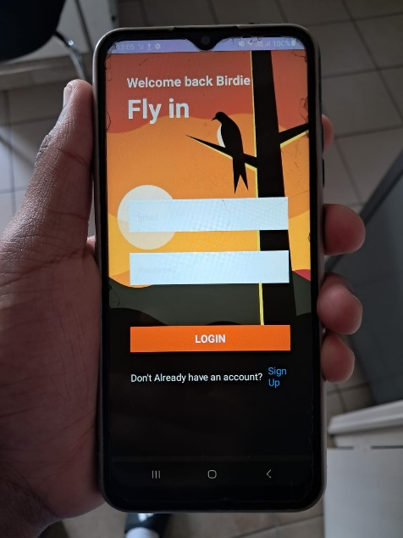We appreciate your continued support and feedback. Please feel free to contact us with any questions or suggestions.

